Ultrasound Nerve Segmentation
Implemented in Keras

Sneha Ravikumar
Northeastern University
ravikumar.s@husky.neu.edu

Abstract—This paper describes an approach to segment the Brachial Plexus using Deep Learning. It involves predicting which pixels of an ultrasound image contain the brachial plexus. The dataset is from 2016 Kaggle competition. Deep learning requires the ability to learn features automatically from the data, which is generally only possible when lots of training data is available. This paper uses the U-NET architecture - a network and training strategy that relies on the strong use of data augmentation to use the available annotated samples more efficiently [1].

INTRODUCTION
In this project, I attempt to segment medical ultrasound images using convolutional neural networks (CNNs). We train CNNs using these images and human segmentation results in the training set. The CNNs are then used to to segment ultrasound images in the test set, and the outputs are segmentation masks.
The model is given a grayscale image as input and should output a binary image (a binary mask). Some images (about 60% of the training set) do not contain the Brachial plexus area and should therefore have an empty mask.
The main idea is that after each convolutional block, information travels along two pathways. One way is down a traditional down-sampling/max-pooling path that you would see in most CNNs and the other is a skip-type connection that merges with a convolutional block of the same volume, that is the result of an up-sampling path.

I.business value

Patient Pain Management post surgey
Even the bravest patient cringes at the mention of a surgical procedure. Surgery inevitably brings discomfort, and oftentimes involves significant post-surgical pain. Currently, patient pain is frequently managed with narcotics that bring a bevy of unwanted side effects. Indwelling catheters that block or mitigate pain at the source can be used as an alternate thus reducing the dependency on narcotics and speed up patient recovery.

Medical Requirements
Other applications of onsist of border detection in angiograms of coronary, surgical planning, simulation of surgeries, tumor detection and segmentation, brain development study, functional mapping, blood cells automated classification, mass detection in mammograms, image registration, heart segmentation and analysis of cardiac images

II.Dataset and evaluation

In this project, we used one publicly available dataset from one of the Kaggle challenges (Kaggle, 2016). It contains ultrasound images acquired on human necks, and the aim is to segment a collection of nerves called the Brachial Plexus (BP). The data set contains a training set that has been segmented by trained volunteers, and a test set. One example of the original image and its segmentation by human volunteers are shown in Fig. 1. Each image has 420 × 580 pixels.

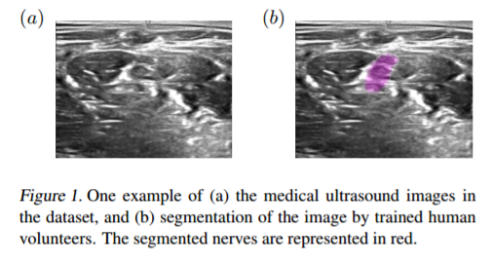The dataset imposes additional challenges to the segmentation task. As shown by the example, the region of interest (ROI) does not have a clear boundary against surroundings, and shares very similar texture with the rest of the image. No obvious feature is present. In addition, as described by the Kaggle challenge website, human mislabeling are to be expected. Participants of the challenge reported obvious mistakes by volunteers that segmented the images. False positives and false negatives in the identification of the nerves were reported as well. These factors contribute to the challenges of the task. This is the only large and publicly available ultrasound image data set we could find that has been segmented and is allowed to be used.

This competition is evaluated on the mean Dice coefficient. The Dice coefficient can be used to compare the pixel-wise agreement between a predicted segmentation and its corresponding ground truth.

III . Approach

